ISSACK WAITHAKA
cs-sa07-24085

Introduction
- We are going to learn about the ffuf tool for web fuzzing.
- Fuzzing is testing technique that sends various inputs to an interface to see how it reacts
- We use wordlists which contains commonly used words for web directories

ffuf
- It has only two options, The -w for wordlists and -u for the url

Questions
1.
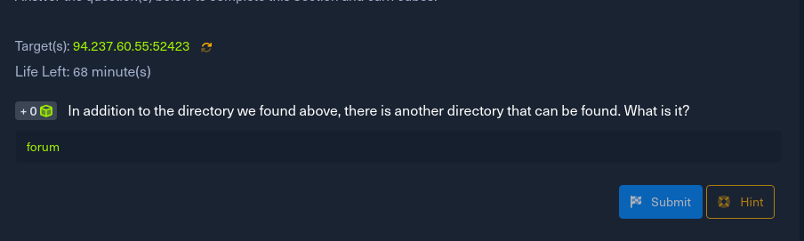
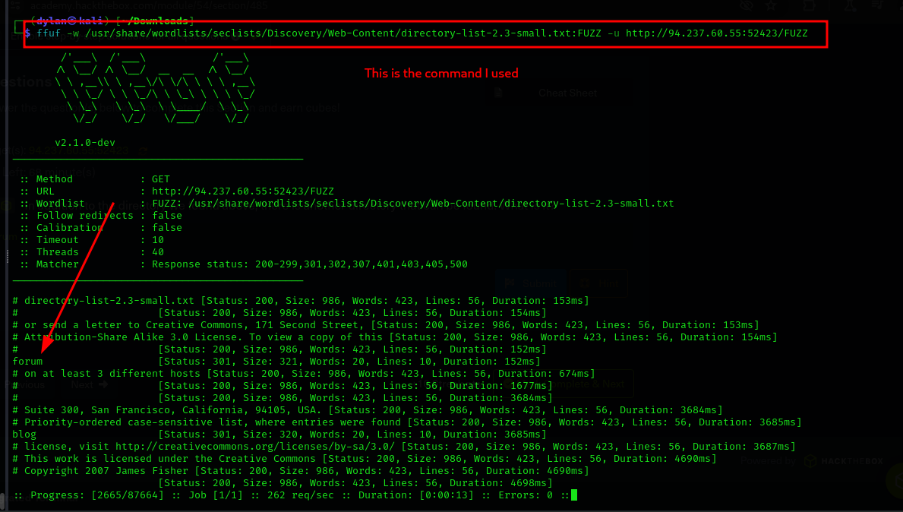

Page fuzzing
Questions
1.
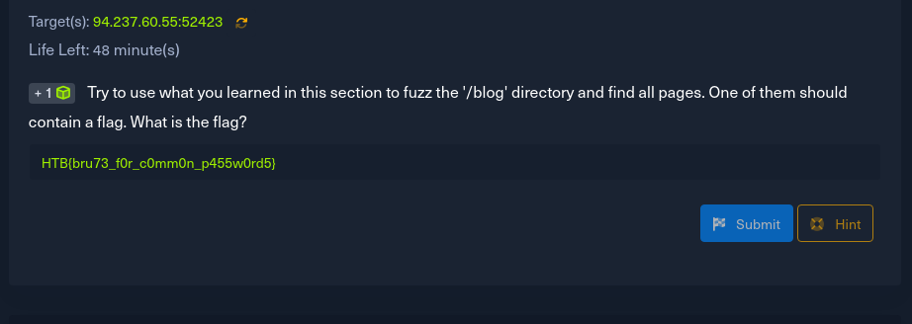
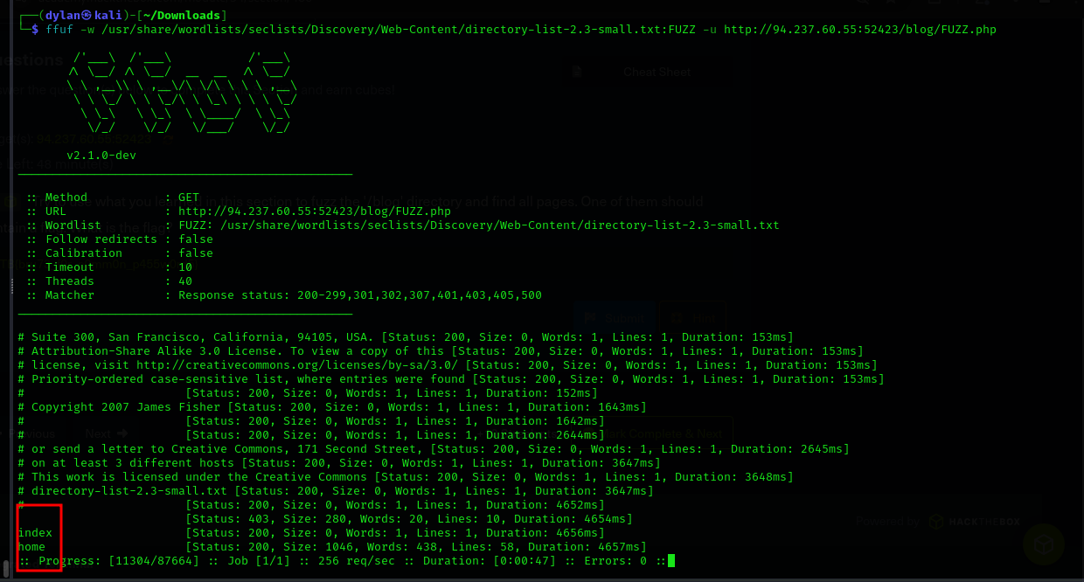

- I was able to get the two, Index.php was blank and I decided to use home.php where I was able to get the flag.
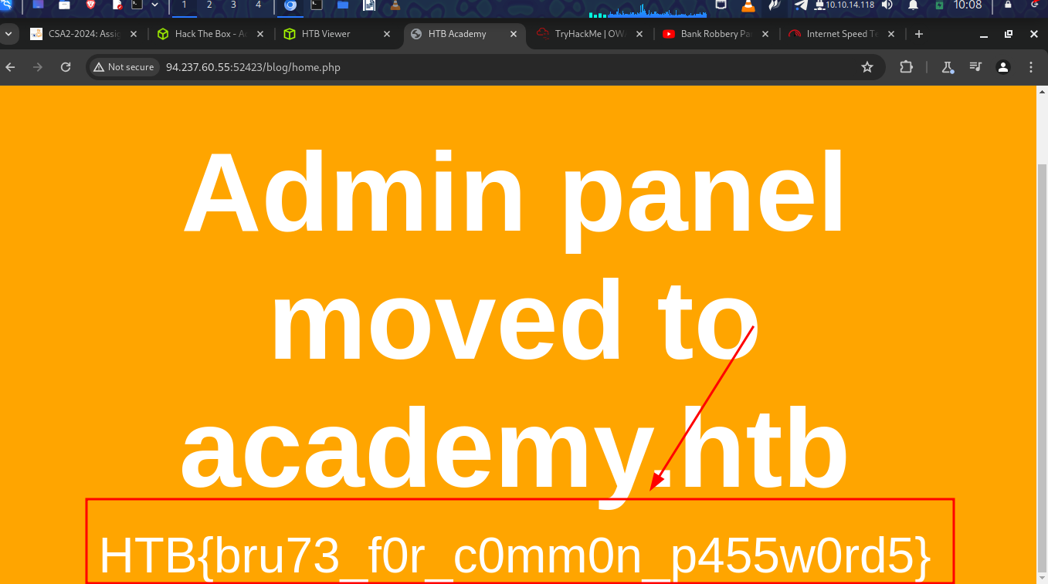
-

Recursive Fuzzing
- This helps us when we are dealing with dozens of subdirectories with each having files
- If We specify the recursion-depth it will only ffuf the directory and their sub-directories

Questions
1.
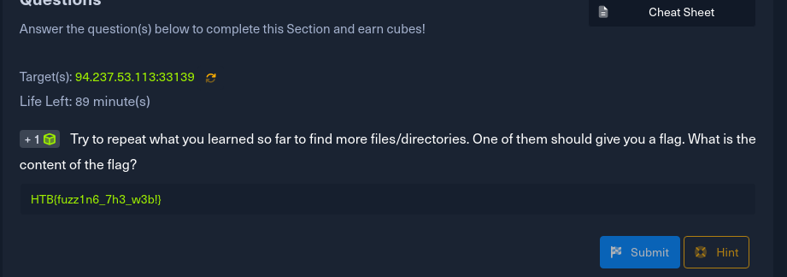
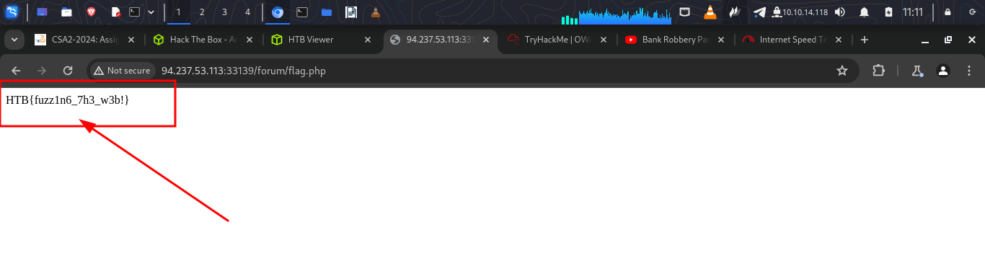

Sub-domain fuzzing
- A sub-domain is a website underlying another domain

Questions
1.
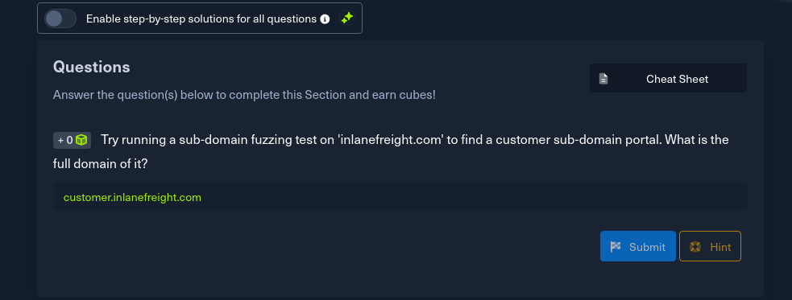
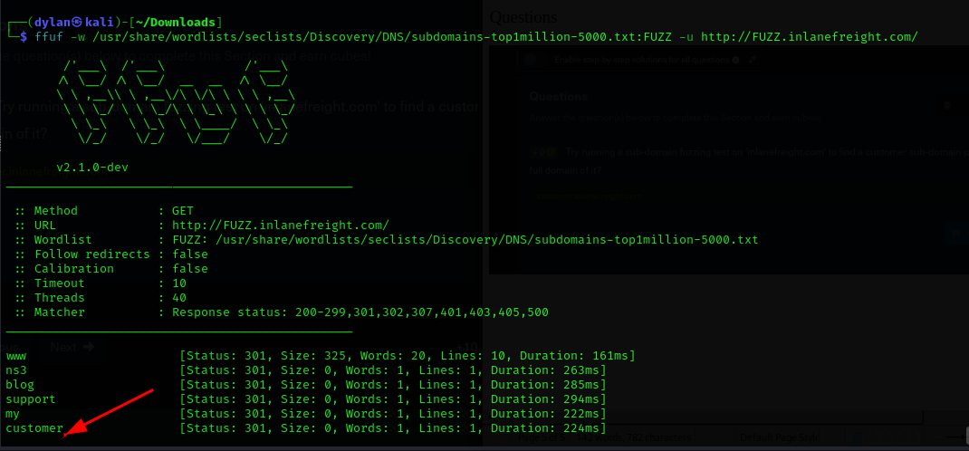

Vhost fuzzing
- Vhost is a sub-domain served from the same server and has the same IP such as a single IP could be serving.
- Vhost fuzzing will identify both public and non-public subdomains and Vhosts

Questions
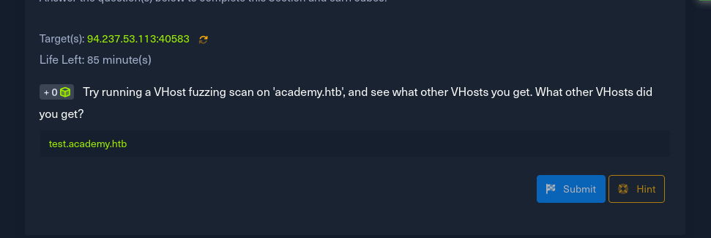
-
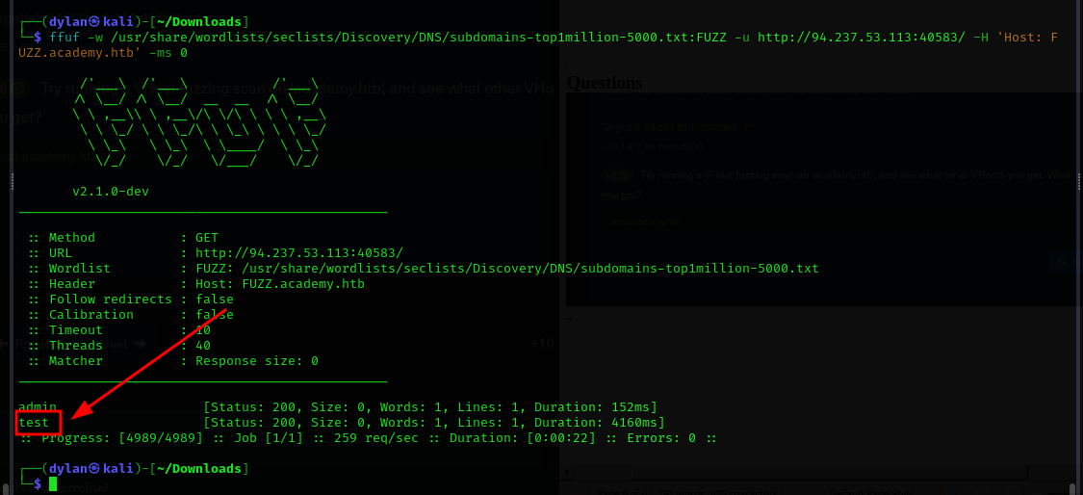

Parameter Fuzzing – Get
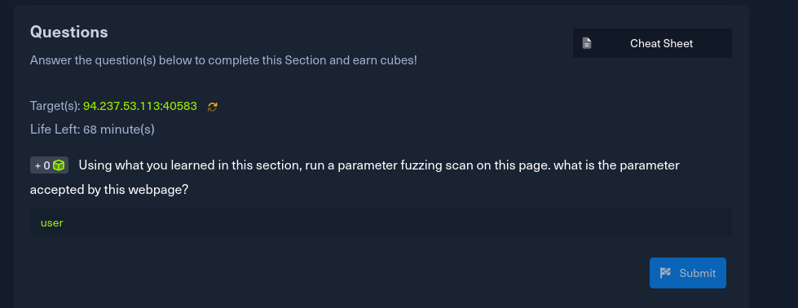
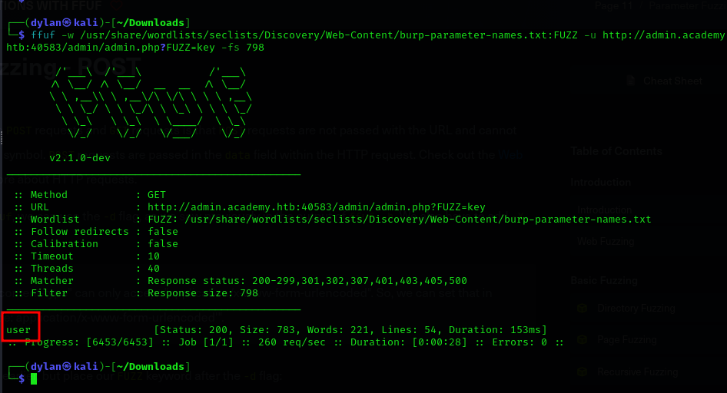
Value Fuzzing
Questions
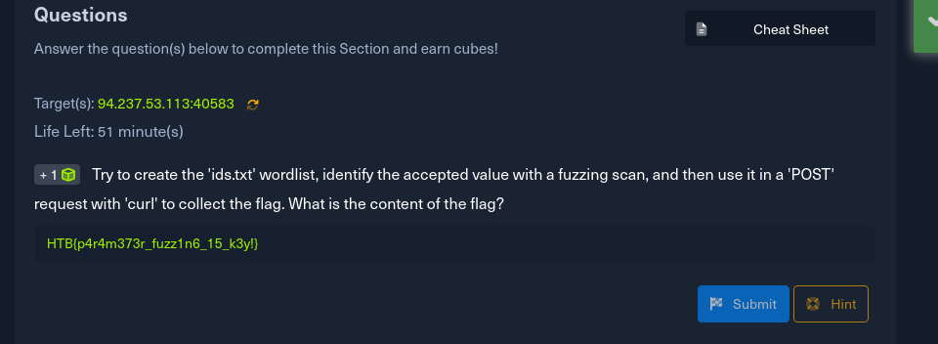
a. first step was to create the wordlists
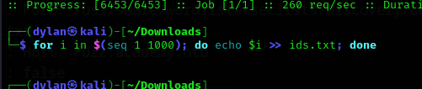

b.
We then run ffuf to identify the parameter name
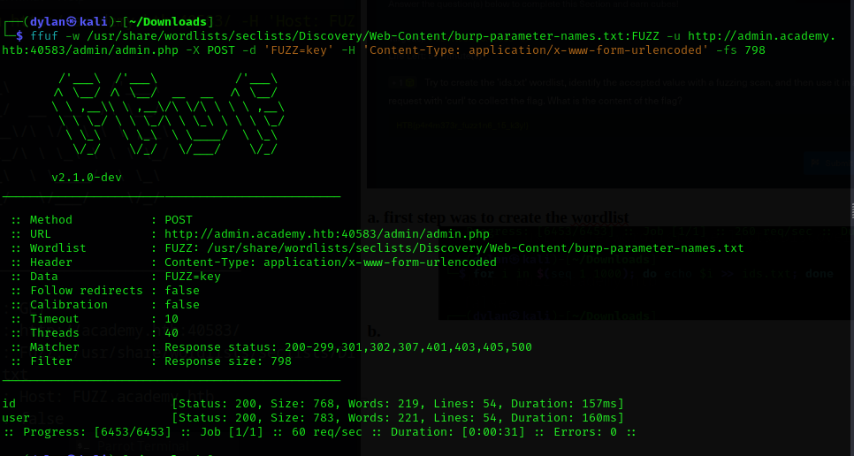
c. Now we used the parameter name against the parameter wordlists we created and we got id number as 73
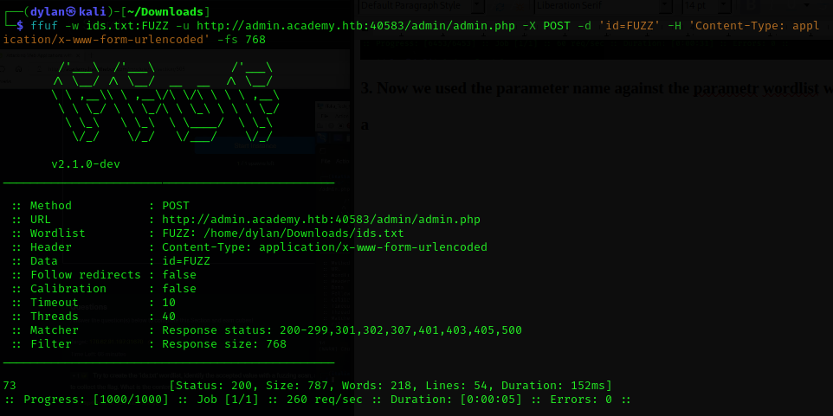
d.
We used curl to get the flag
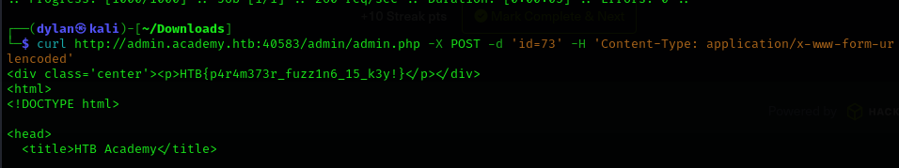

Skill Assessment – Web Fuzzing
1.
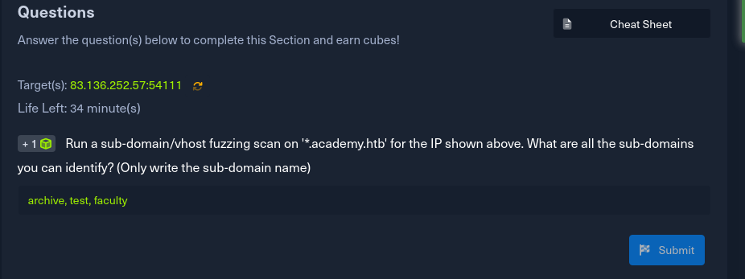
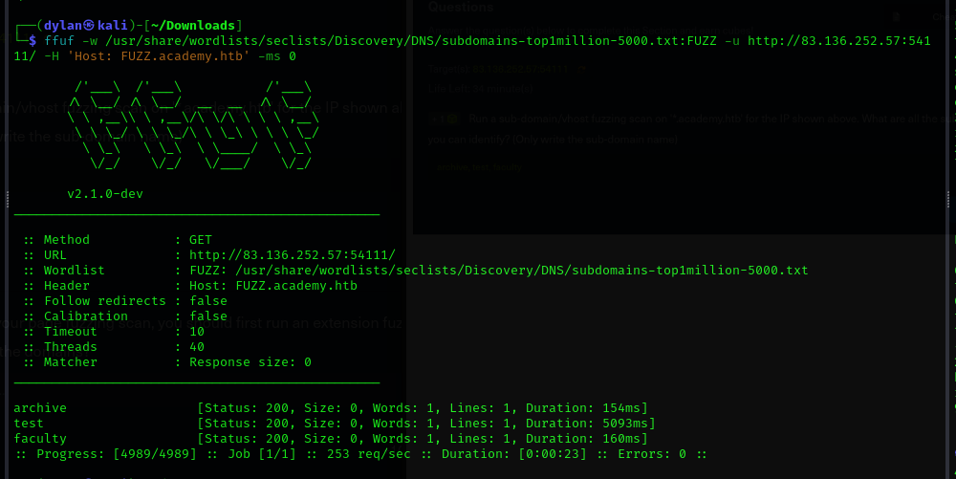
2.
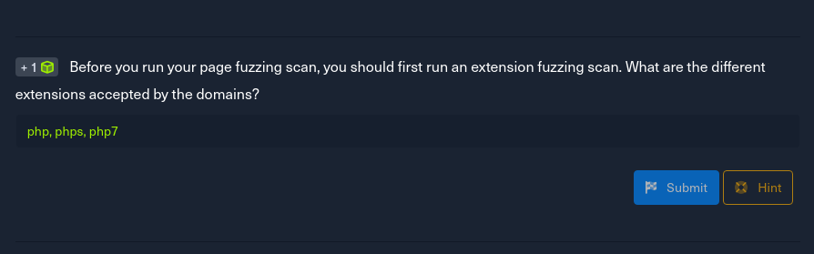
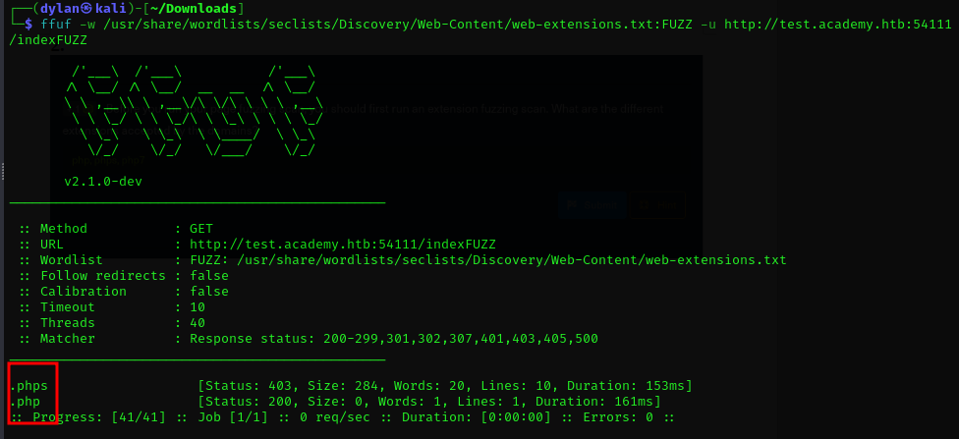

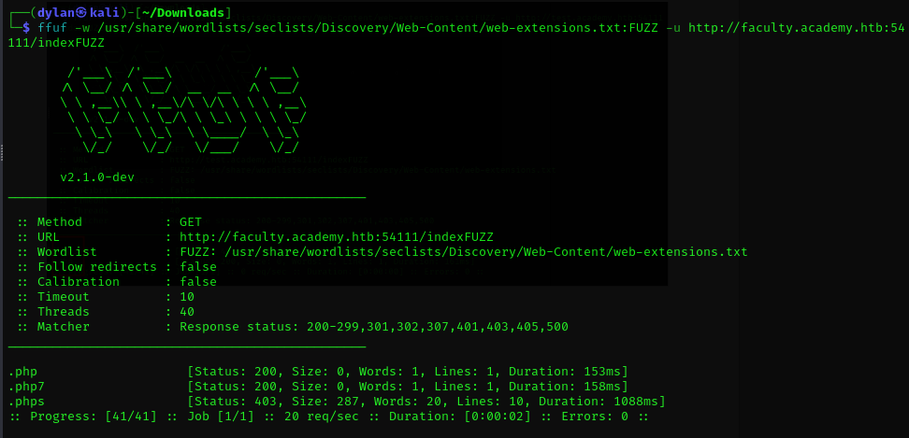
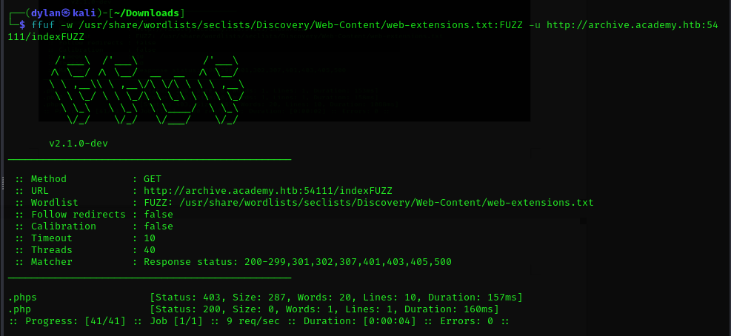
3,
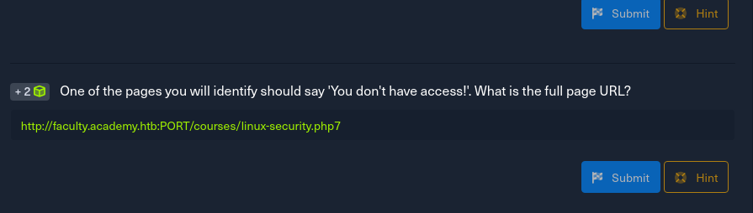
I ffuf the the faculty directories and got the courses directory in it.
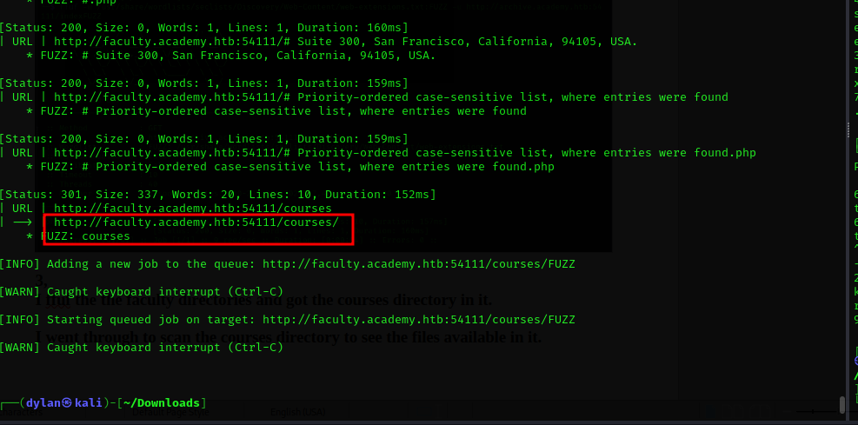
I went through to scan the courses directory to see the files available in it.
I tried a bunch of the results and only one of them turned out
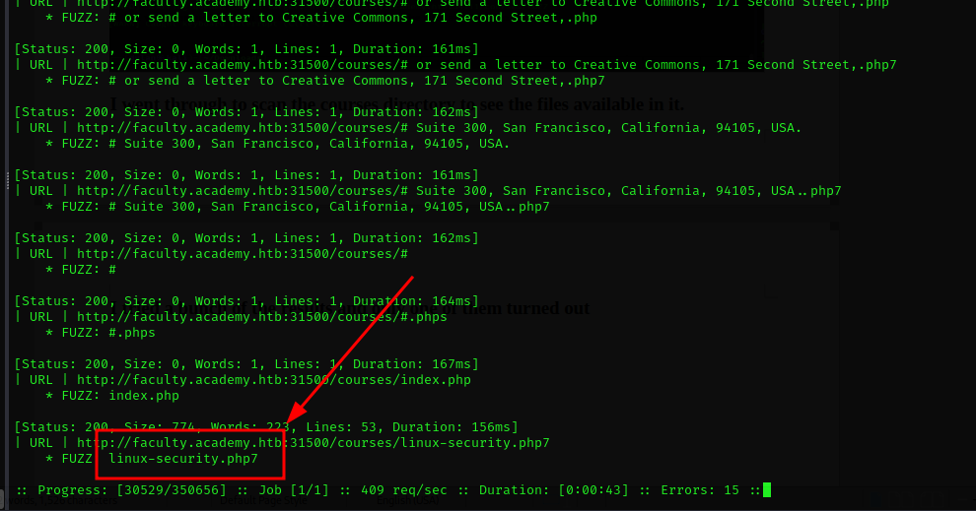

4.
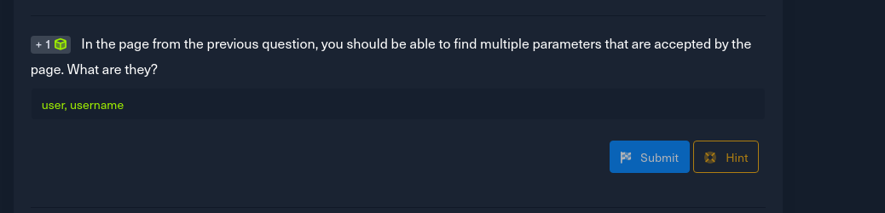
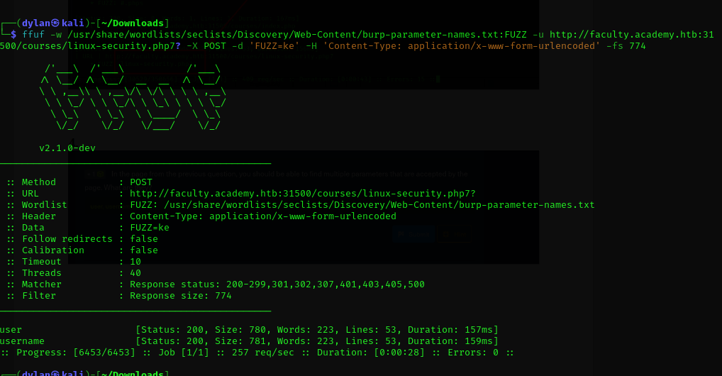
5.
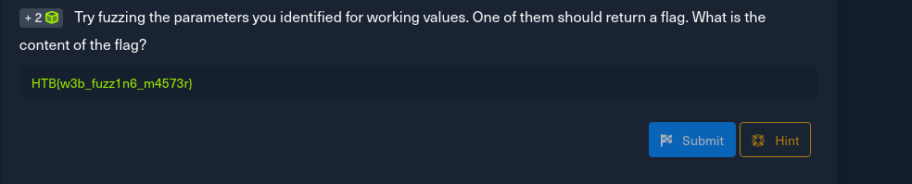
I was able to get the username
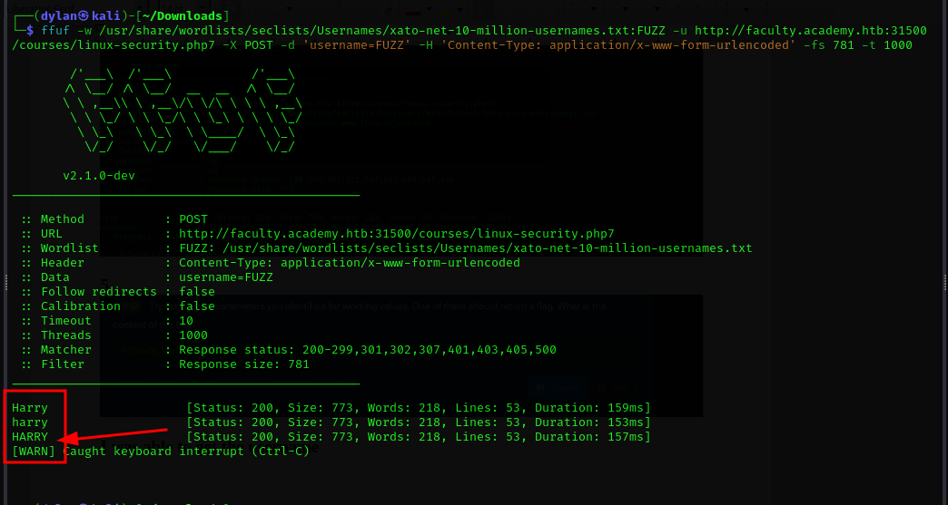
The I used curl to the flag
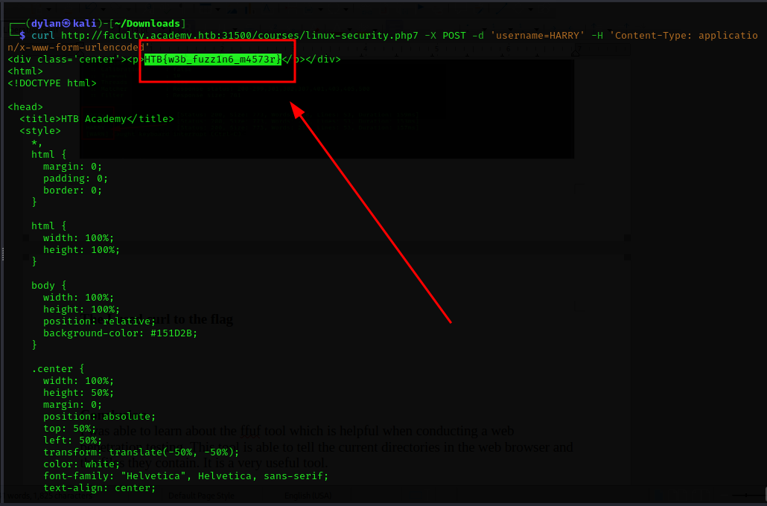
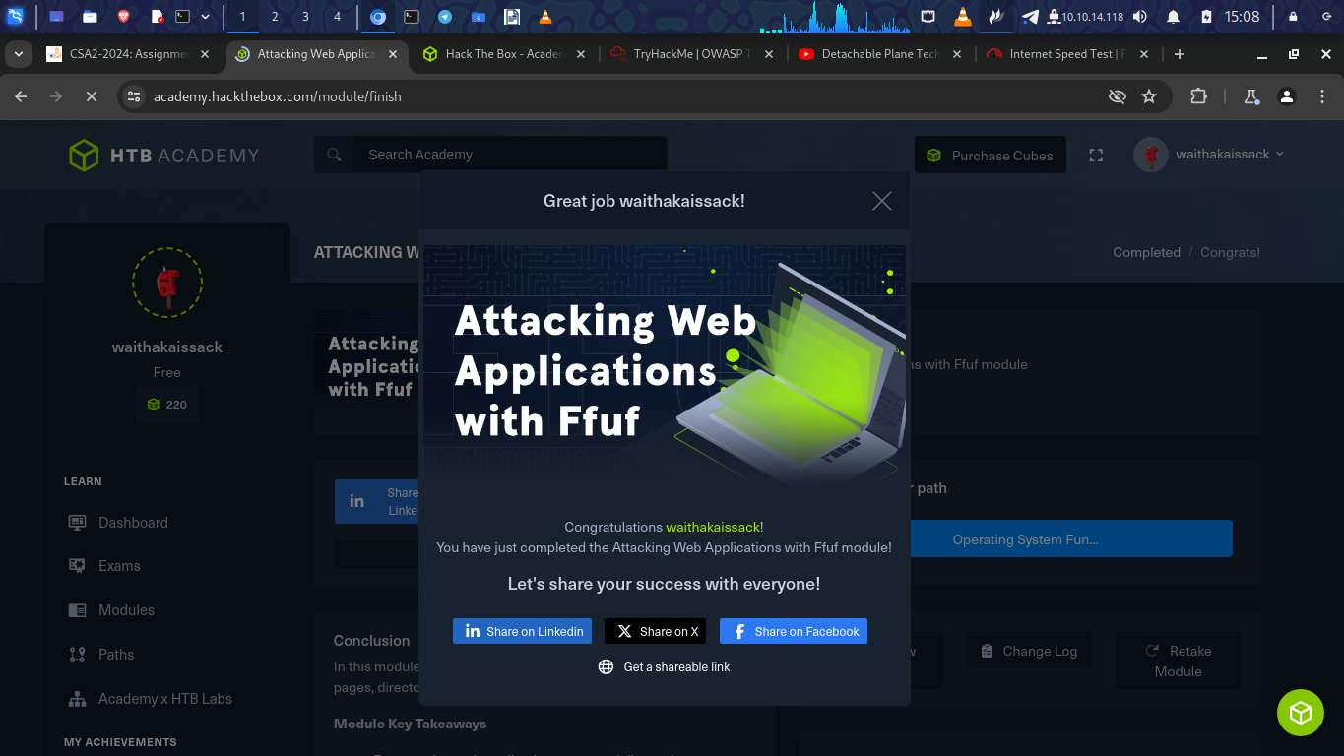
https://academy.hackthebox.com/achievement/798750/54

Conclusion
I was able to learn about the ffuf tool which is helpful when conducting a web penetration testing. This tool is able to tell the current directories in the web browser and the files they contain. It is a very useful tool.

